Tweets and Facebook Posts for Diabetes Alert Day 2018

*Copy and past the following social media posts into your Twitter and Facebook pages.*

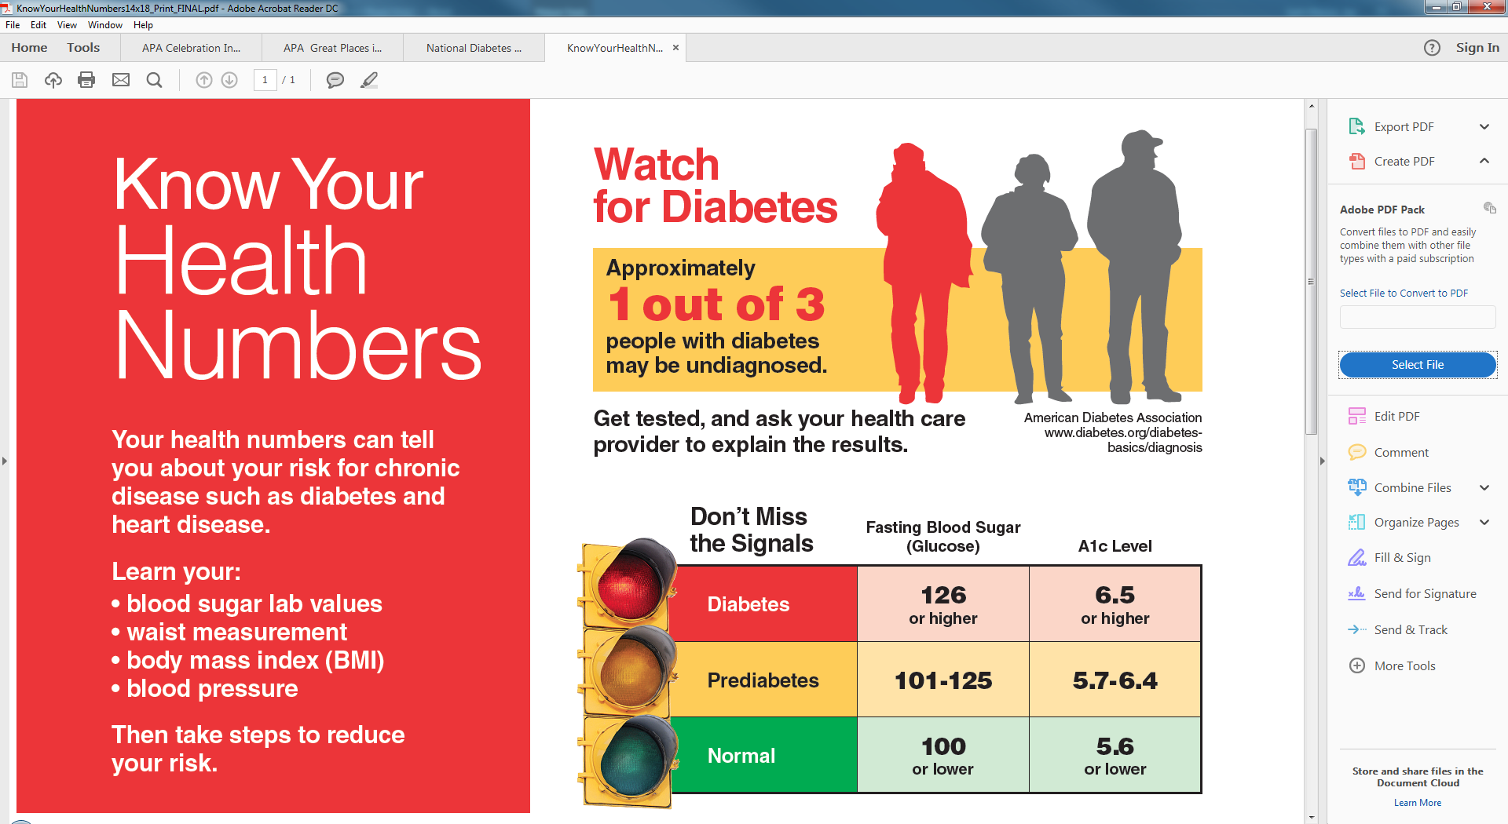

Tuesday, March 27 is Diabetes Alert Day. Get checked for diabetes or prediabetes.  
[diabetesfreenc.com/for-you](http://www.diabetesfreenc.com/for-you/) #DiabetesAlertDay



Take a loved one to get checked for diabetes or prediabetes. Visit [diabetesfreenc.com/for-you](http://www.diabetesfreenc.com/for-you/) #DiabetesAlertDay



Diabetes is the 7th leading cause of death in North Carolina. Get checked. [diabetesfreenc.com/for-you](http://www.diabetesfreenc.com/for-you/) #DiabetesAlertDay



 Take the Diabetes Risk Test on [diabetesfreenc.com/for-you](http://www.diabetesfreenc.com/for-you/). #DiabetesAlertDay



Learn how physical activity can reduce your risk of type 2 diabetes. [diabetesfreenc.com/for-you](http://www.diabetesfreenc.com/for-you/) #DiabetesAlertDay



Prediabetes puts you at risk for heart disease and stroke. Decrease your risk. [diabetesfreenc.com/for-you](http://www.diabetesfreenc.com/for-you/) #DiabetesAlertDay