**Diabetes Advisory Council 2018 DAC Awards  
Social Media Posts**

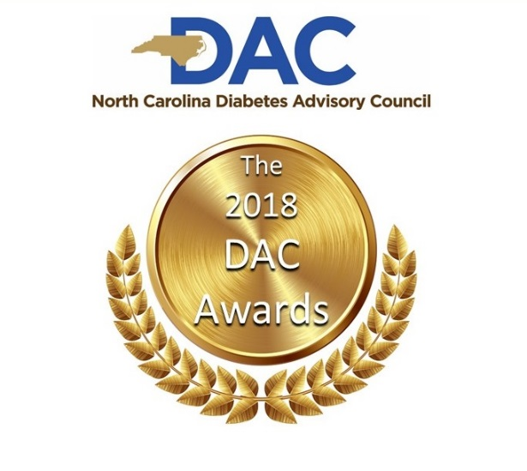

Nominate your diabetes prevention or management champion at [diabetesnc.com/dac](http://www.diabetesnc.com/partner_ncdac.php)

#DACAWARDS



How do you thank someone for helping you prevent or manage diabetes? Nominate them for a DAC Award at [diabetesnc.com/dac](http://www.diabetesnc.com/partner_ncdac.php). #DACAWARDS



The 2018 Diabetes Advisory Council Prevention and Management Awards are here. Nominate your hero today at [diabetesnc.com/dac](http://www.diabetesnc.com/partner_ncdac.php). #DACAWARDS



Show your employer, doctor, coach or friend that you appreciate their help in your fight against diabetes. [diabetesnc.com/dac](http://www.diabetesnc.com/partner_ncdac.php). #DACAWARDS

A person with collar shirt

Description generated with high confidence

Got a diabetes prevention or management hero? Nominate them for a Diabetes Advisory Council Award at [diabetesnc.com/dac](http://www.diabetesnc.com/partner_ncdac.php). #DACAWARDS