National Diabetes Awareness Month

Social Media Posts

Twitter

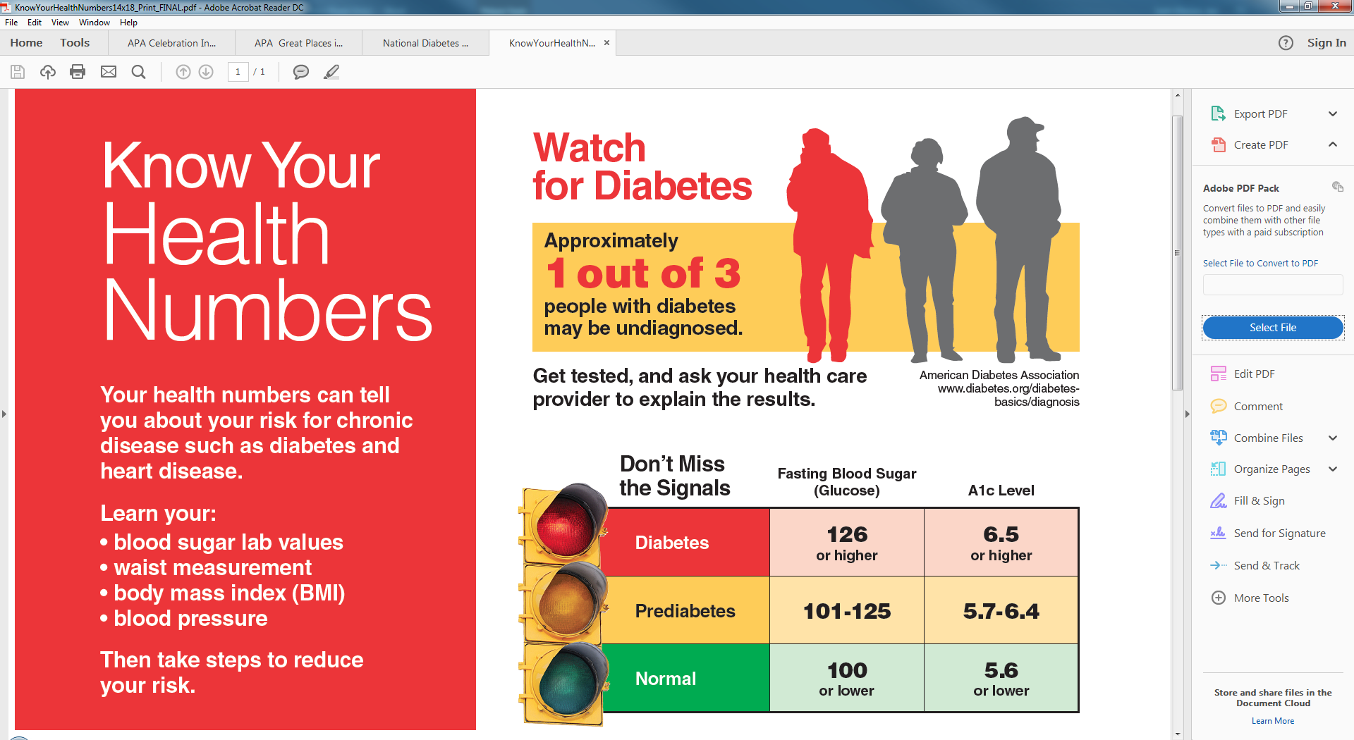

November is #NationalDiabetesAwarenessMonth. Get checked for Diabetes.

March <https://goo.gl/TejkGq>

Learn how physical activity can reduce your risk of type 2 diabetes. <https://goo.gl/D2SPuc> #DiabetesAwarenessMonth

Learn about healthy eating habits to reduce your risk of diabetes. <https://goo.gl/D2SPuc> #DiabetesAwarenessMonth



Learn how patient screenings can benefit patients and health care professionals. <http://bit.ly/2e7cmUq> #DiabetesAwarenessMonth

Find out if you are at risk for type 2 diabetes. Take this quiz and talk with a health care professional. <https://goo.gl/TejkGq>

Take a loved one to get checked for diabetes. Visit <https://goo.gl/Pyb7pm>

#DiabetesAwarenessMonth

Diabetes is the 7th leading cause of death in North Carolina. Get checked. <https://goo.gl/TejkGq>

#DiabetesAwarenessMonth

November is #NationalDiabetesAwarenessMonth. Take the Diabetes Risk Test on <https://goo.gl/TejkGq>

If you have diabetes, remember to get your flu shot. [www.cdc.gov/flu/diabetes/index.htm](http://www.cdc.gov/flu/diabetes/index.htm) #DiabetesAwarenessMonth

Eat Smart and Move More to help manage your blood sugar. [eatsmartmovemorenc.com](http://eatsmartmovemorenc.com/)

#DiabetesAwarenessMonth

Diabetes is manageable, Diabetes Self-Management Education can help. [diabetesnc.com/about_management.php](http://diabetesnc.com/about_management.php)



You can’t manage your blood sugar unless you know your numbers. #DiabetesMonth [preventchronicdiseasenc.com/control_blood_sugar.php](http://preventchronicdiseasenc.com/control_blood_sugar.php)

Twitter Handles to Follow

[@CDCDiabetes](https://twitter.com/CDCDiabetes?ref_src=twsrc%5Egoogle%7Ctwcamp%5Eserp%7Ctwgr%5Eauthor): CDC’s Division of Diabetes Translation

[@AmDiabetesAssn](https://twitter.com/AmDiabetesAssn?ref_src=twsrc%5Egoogle%7Ctwcamp%5Eserp%7Ctwgr%5Eauthor): American Diabetes Association

Facebook

Increased physical activity has been shown to reduce the risk of type 2 diabetes. November is National Diabetes Awareness Month. Learn about the many benefits of physical activity. [diabetesnc.com/about_prevention.php](http://www.diabetesnc.com/about_prevention.php)

November is National Diabetes Awareness Month. Find out if you are at risk for type 2 diabetes. Visit CDC’s National Diabetes Prevention Program website and take the online quiz or print a screening test. Talk about your results with a health care professional. <http://bit.ly/2eQY249>

A healthy diet is an important part of preventing diabetes. This National Diabetes Awareness Month, learn ways to make healthy eating a part of your lifestyle. <http://bit.ly/2ewpxwG>

November is National Diabetes Awareness Month. Health care professionals can play an important role in preventing type 2 diabetes. Find out if you are at risk for prediabetes and type 2 diabetes by taking this screening test. Talk with a health care professional. <https://goo.gl/TejkGq>

You can’t manage your blood sugar unless you know your numbers. [preventchronicdiseasenc.com/control_blood_sugar.php](http://preventchronicdiseasenc.com/control_blood_sugar.php)

