USE THESE TWEETS TO HELP PROMOTE #AmericanDiabetesMonth
(Source http://ndep.nih.gov/publications/PublicationDetail.aspx?PubId=72)
Know the ABC’s of managing diabetes. http://www.diabetesnc.com/about_management.html #AmericanDiabetesMonth

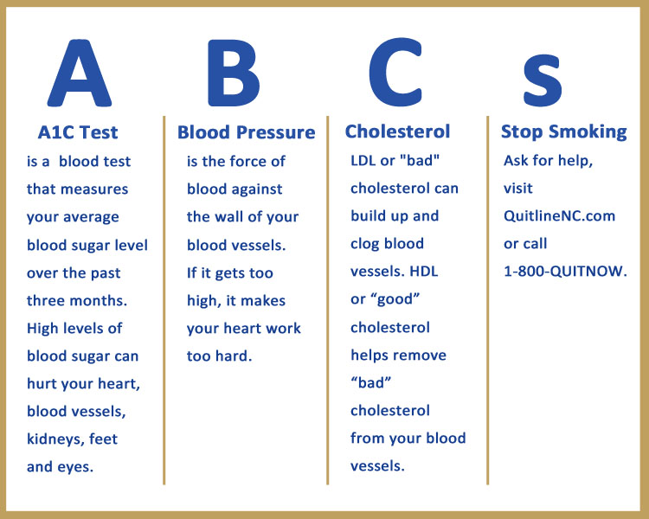

These 8 easy outdoor exercises will help you get stronger, faster, slimmer! #diabetes http://bit.ly/1RqPzhF pic.twitter.com/1NsHHXTMwU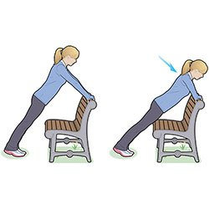
Small steps gain big rewards. Try walking after dinner to help reduce your risk of developing diabetes. #StopDiabetes #AmericanDiabetesMonth
Eat slowly. It takes 20 minutes for your stomach to tell your brain you are full. Don’t over eat #HealthTips #AmericanDiabetesMonth
Turn up your music and jam to your household chores. Not only will your mood be lifted, so will your endorphins #DanceItOut #HealthTips #AmericanDiabetesMonth
Work out to a video that shows you how to get active. #HealthTips #AmericanDiabetesMonth
March in place while you watch TV. #HealthTips #AmericanDiabetesMonth
Make at least half of your grains whole grains, such as whole grain breads and cereals, brown rice, and quinoa. #HealthTips #AmericanDiabetesMonth
Use whole grain bread for toast and sandwiches. #HealthTips #AmericanDiabetesMonth
Keep a healthy snack with you, such as fresh fruit, a handful of nuts, and whole grain crackers. #HealthTips #AmericanDiabetesMonth
Slow down at snack time. Eating a bag of low-fat popcorn takes longer than eating a candy bar. #HealthTips #AmericanDiabetesMonth
Share a bowl of fruit with family and friends. #HealthTips #AmericanDiabetesMonth
Eat a healthy snack or meal before shopping for food. Do not shop on an empty stomach. #HealthTips #AmericanDiabetesMonth
Shop at your local farmers market for fresh, local food. #HealthTips #AmericanDiabetesMonth
Make a list of food you need to buy before you go to the store. #HealthTips #AmericanDiabetesMonth
Keep a written record of what you eat for a week. It can help you see when you tend to overeat or eat foods high in fat or calories. #HealthTips #AmericanDiabetesMonth
Honor your health as your most precious gift. There are many more ways to prevent or delay type 2 diabetes by making healthy food choices and moving more. #HealthTips #AmericanDiabetesMonth
Find ways to stay calm during your day. Being active and reading a good book can help you lower stress. #StopDiabetes #AmericanDiabetesMonth
Keep track of the many ways you are moving more and eating healthy by writing them down. #StopDiabetes #AmericanDiabetesMonth
Stir fry, broil, or bake with non-stick spray or low-salt broth. Cook with less oil and butter. #StopDiabetes #AmericanDiabetesMonth
Know the ABC’s of managing diabetes. http://www.diabetesnc.com/about_management.html #AmericanDiabetesMonth
Drink a large glass of water 10 minutes before your meal so you feel less hungry #HealthTips #AmericanDiabetesMonth
Cook with smaller amounts of cured meats (smoked turkey and turkey bacon). They are high in salt. #HealthTips #StopDiabetes #AmericanDiabetesMonth
Cook with a mix of spices instead of salt. #HealthTips #AmericanDiabetesMonth
Try different recipes for baking or broiling meat, chicken, and fish. #HealthTips #AmericanDiabetesMonth
Choose foods with little or no added sugar to reduce calories. #HealthTips #AmericanDiabetesMonth
Try not to snack while cooking or cleaning the kitchen. #HealthTips #AmericanDiabetesMonth
Find a diabetes self-management education program in NC. Visit DiabetesNC.com #AmericanDiabetesMonth
Learn how to #CreateYourPlate for healthy meals, all year round: http://www.diabetes.org/food-and-fitness/food/planning-meals/create-your-plate/?loc=hhm
Non-starchy veggies, grains, protein, healthy fats, low-calorie drink = #CreateYourPlate http://diabetes.org/hhm
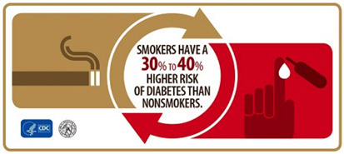
For other risk factors, visit DiabetesNC.com
_{Refer}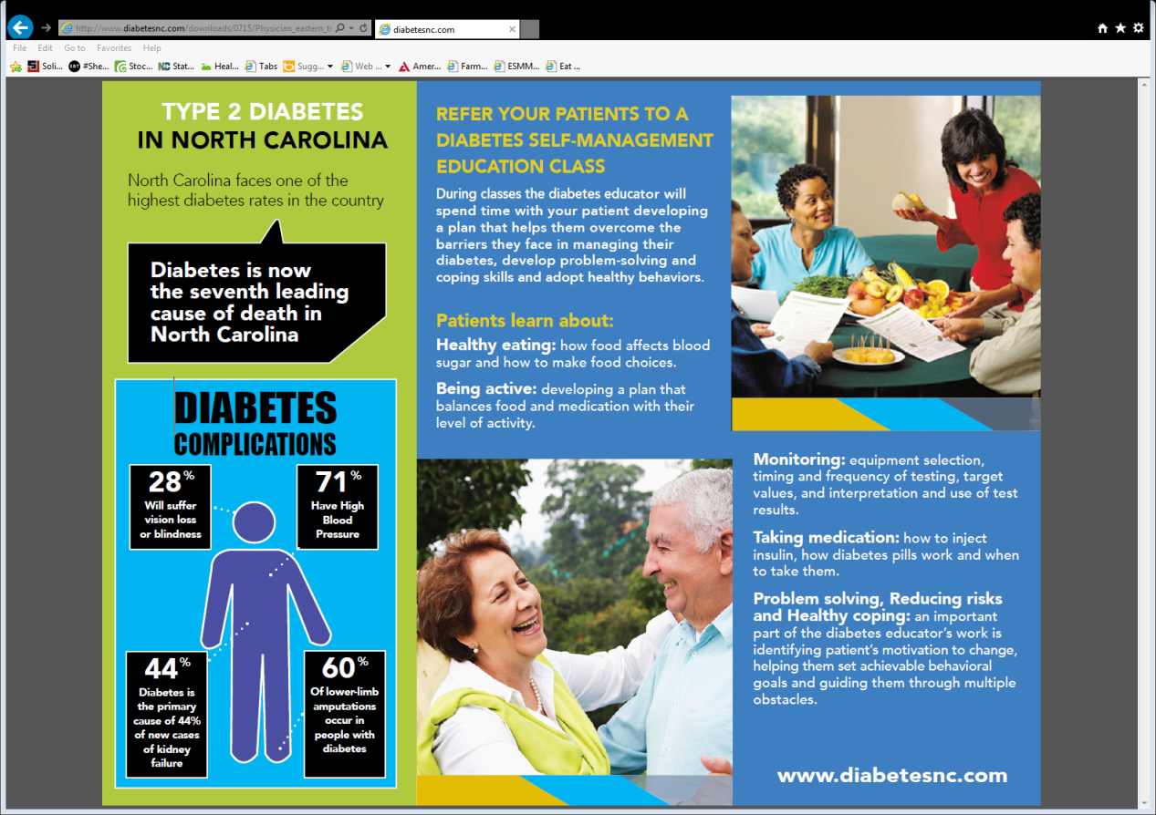
Refer your patients to a diabetes self-management education class, visit DiabetesNC.com

Eating at home is usually a much better choice, but eating out doesn’t have to be a health disaster. #FridayFact pic.twitter.com/wEioLQfnmj
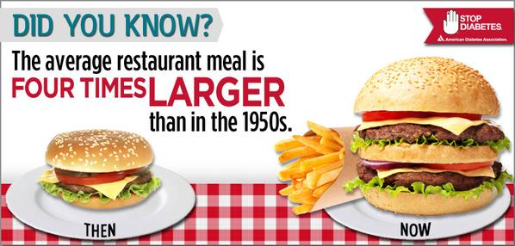

USE THESE TWEETS AND PICTURES TO TAKE #JustOneStep
TO HELP CREATE A HEALTHIER NC
(Campaign Hashtag #AmericanDiabetesMonthand #JustOneStep)
TWEET | PICTURE
Spice up your shopping list with seasonal vegetables takes you #JustOneStep toward  managing type 2 diabetes! @NDEP #AmericanDiabetesMonth | 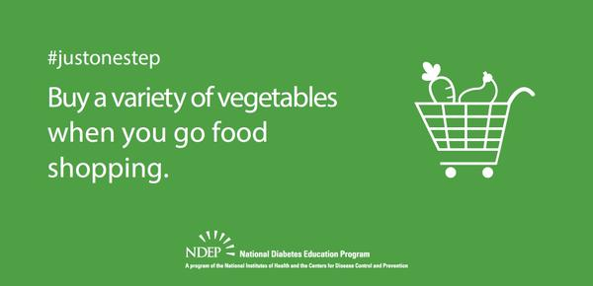
Here’s another #JustOneStep tip: Take the stairs to your office instead of the elevator. #AmericanDiabetesMonth | 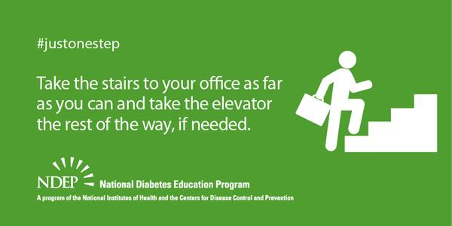
Take advantage of today's weather to catch up with friends during a walk instead of by phone. #JustOneStep @NDEP #AmericanDiabetesMonth | 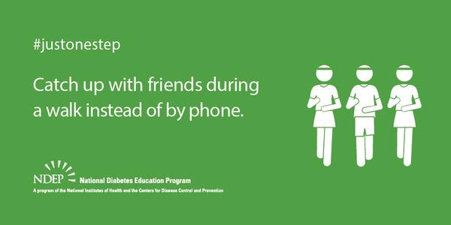
Here’s a #JustOneStep tip: keep meat, chicken, turkey & fish portions to about 3 ounces (the size of a deck of cards) #AmericanDiabetesMonth | 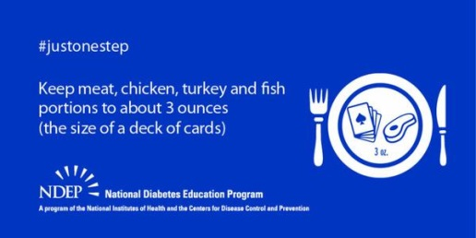
Type 2 #diabetes doesn't have to be a family affair. Bust a move with your kids today! #JustOneStep @NDEP #AmericanDiabetesMonth | 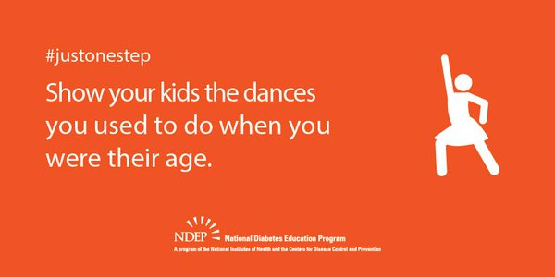
Better manage your #diabetes by serving your meal on a smaller plate to make less look like more! #JustOneStep @NDEP #AmericanDiabetesMonth | 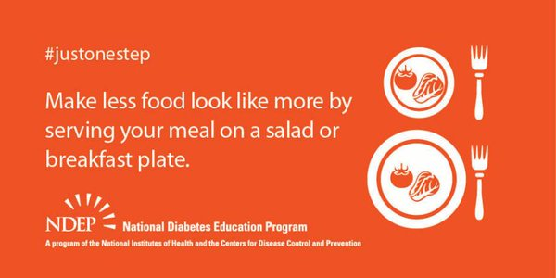
Here’s another #justonestep tip: Choose brown rice instead of white rice. #AmericanDiabetesMonth | 